
ALMAAREFA University
College of Applied Scineces
Department of Computer Science and Information Systems
Cyber Attack Simulation LAB
English:
Arabic:

Team members:
ID | Name
22112014 | ABDULRAHMAN MOHAMMED ALANAZI
221120258 | TALAL FAHAD ALANAZI

Supervisor:

DR / ISMAIL MOHAMMED KESHTA
A report submitted in part fulfilment of the degree of BSc in [Computer Science /Information Systems/ Health Information Systems]
2024 – 2025

Contents
Abstract: 1
Chapter One: Introduction 3
1.1: Introduction: 3
1.2 Project Description: 3
1.3 Project Purpose: 3
1.4 Problem Statement: 3
1.5 The System Context View: 3
1.6 System Requirements: 3
1.8 Challenges: 3
1.9 Projection: 3
1.10 Ethical Considerations 3
Chapter Two: Literature Review 4
2.1: Background 4
2.2: Literature Review 4
2.3 The Existing Solutions 4
Chapter Three: System Architecture and Design 5
3.1 Introduction: 5
3.2 Methodology: 5
3.3 System Architecture 5
3.4 Structural model 5
3.5 Detailed System Architecture 5
3.6 User Interface 5
3.7 Quality Assurance 5
3.8 Acceptance Criteria 5
3.9 Future Consideration 5
Chapter Four: Experimental Setup and Configuration 6
4.1 Hardware and Software Setup: 6
4.2 Installation and Configuration: 6
4.3 Tools and Technologies Used: 6
4.4 System Training (for AI systems) 6
4.5 Testing and Validation: 6
4.6 Risk Analysis and Mitigation: 6
Chapter Five: Results and Discussion 7
5.1 Results: 7
5.2 Discussion: 7
5.3 Limitations: 7
Chapter Six: Conclusion 8
6.1 Summary of Work: 8
6.2 Lessons Learned: 8
6.3 Future Work: 8
References 9
Appendices 10
A1. Project Timeline 10
A2. Source Code Documentation 10
A3. User Manuals 10
A4. Additional Diagrams 10

Abstract:

Chapter One: Introduction

1.1: Introduction:
In today’s digital era, cybersecurity has become a critical discipline for protecting systems, networks, and information from increasing cyber threats. As cyberattacks grow more advanced and frequent, the need for hands-on training environments has become essential.
The Cyber Attack Simulation Lab provides a secure, isolated, and controlled environment that allows students and cybersecurity professionals to practice, analyze, and improve their defensive and analytical skills. Through realistic attack simulations, users gain practical experience in identifying, mitigating, and preventing cybersecurity incidents.

1.2 Project Description:

The Cyber Attack Simulation Lab is designed to emulate real-world cyberattacks—such as phishing, ransomware, privilege escalation, and network breaches—within a safe virtual environment.

This project enables learners to observe and understand attacker behavior, system reactions, and defensive responses. The lab provides an interactive and hands-on approach to strengthen both technical and analytical cybersecurity skills.

1.3 Project Purpose:

The primary purpose of this project is to create a practical learning environment where users can engage directly with simulated cyberattacks rather than relying solely on theoretical knowledge.

The lab aims to:

Enhance students’ understanding of how attacks unfold.

Improve incident response and mitigation skills.

Build confidence in using cybersecurity tools.

Develop analytical thinking through real-time threat analysis.

1.4 Problem Statement:

Traditional cybersecurity education often lacks realistic, practical exposure. Many learners struggle to understand how attacks occur and how to respond effectively because the training is limited to theory.

This lack of hands-on experience reduces readiness for real cybersecurity challenges.

The Cyber Attack Simulation Lab addresses this gap by providing a safe, isolated environment where students can experiment, practice offensive and defensive techniques, and learn without risking damage to real systems or networks.

1.5 The System Context View:

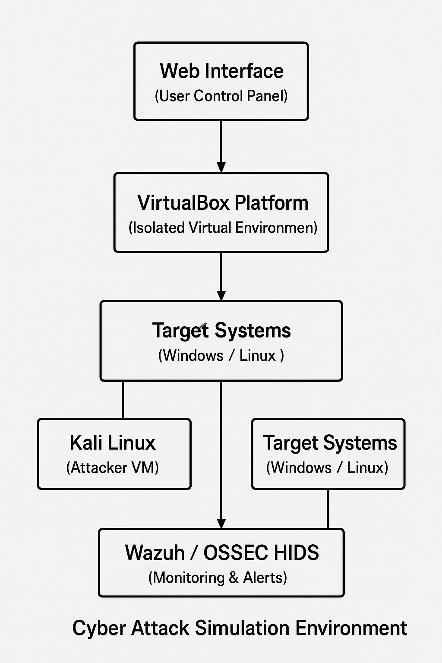

1.6 System Requirements:
- Hardware Requirements:
  - Minimum 8 GB RAM and multi-core processor.
  - Sufficient disk space for multiple VMs.
- Software Requirements:
  - VirtualBox for virtualization.
  - Kali Linux and Windows Server/Ubuntu as target systems.
  - Wazuh/OSSEC for monitoring and alerts.
  - Web interface for controlling and viewing simulation activities.

1.8 Challenges:
- Maintaining complete isolation between virtual environments and real networks.
- Managing resource usage while running multiple virtual machines.
- Ensuring accurate and realistic attack simulations.
- Keeping attack tools and defense signatures updated with the latest cybersecurity trends.

1.9 Projection:
In the future, the project can evolve into an advanced online cybersecurity training platform. Artificial intelligence could be integrated to automate attack generation and adaptive defense strategies. The system could also include user progress tracking, performance scoring, and certification capabilities for learners.

1.10 Ethical Considerations
The Cyber Attack Simulation Lab is strictly for educational and ethical purposes. All simulations take place in a secure, isolated environment that prevents harm to real systems. Users must adhere to cybersecurity ethics, laws, and university policies. The project promotes responsible learning and aims to strengthen cyber defense, not to encourage malicious activities.

Chapter Two: Literature Review

2.1: Background

This project belongs to the broader field of cybersecurity education and focuses on simulating cyberattacks within a virtual environment.

The setup includes:

An attacker machine (Kali Linux)

A victim system (Windows Server or Linux)

A monitoring system (Wazuh)

This environment enables learners to fully understand attack lifecycles and practice real-time incident handling in a safe, isolated setting.

2.2: Literature Review

Cybersecurity research emphasizes the importance of hands-on training and realistic simulations.

Studies highlight that:

Virtual environments like VirtualBox help students run multiple machines and observe attack sequences.

Monitoring tools such as Wazuh support log analysis and detection of abnormal behavior.

Combining attack simulation with monitoring significantly improves a learner’s incident response capabilities.

This hybrid approach enhances practical understanding of threats beyond theoretical learning.

2.3 The Existing Solutions
Existing cybersecurity training platforms provide predefined attack scenarios but often lack customization and full network control.
In contrast, building a custom simulation lab with VirtualBox, Kali Linux, Windows Server, and Wazuh provides:
- Greater flexibility
- More realistic training
- The ability to modify or create attack scenarios
- Direct exposure to logs, alerts, and system behavior
This approach offers deeper insight into attack mechanisms and defensive analysis tailored to the learner’s needs.

Chapter Three: System Architecture and Design

3.1 Introduction:
This chapter focuses on the system architecture and design of the Cyber Attack Simulation Lab, which forms the core technical foundation of the proposed project. The system architecture defines how the various components are organized, deployed, and interconnected to create a secure and functional simulation environment. A well-designed architecture is crucial for ensuring system reliability, scalability, and effective learning outcomes.
This chapter also explains how the attacker, target, and monitoring components operate within an isolated virtualized infrastructure. It describes the flow of data and interactions between these components during simulated cyberattacks, providing insight into how attacks are executed, monitored, and analyzed. The role of virtualization technology is emphasized as a key factor in maintaining a safe and controlled environment that prevents any impact on real-world systems or networks.
In addition, the chapter outlines the methodology adopted for developing the system, including the selection of appropriate tools, technologies, and design principles that support hands-on cybersecurity training. Furthermore, the architectural models and UML diagrams presented in this chapter offer a clear visualization of the system structure, component interactions, and deployment strategy, supporting a comprehensive understanding of the overall system design.

3.2 Methodology:
The Cyber Attack Simulation Lab was developed using a structured methodology that emphasizes educational objectives while ensuring realism and security. The methodology includes the following steps:
• Designing an isolated virtual environment using VirtualBox to prevent any interaction with real-world networks.
• Configuring virtual machines with defined roles, including an attacker machine, a target system, and a monitoring system.
• Implementing realistic cyberattack scenarios in a controlled manner using Kali Linux tools.
• Monitoring system behavior and analyzing logs during the execution of attacks.
• Applying detection and response mechanisms to evaluate the effectiveness of defensive measures.
• Analyzing the results and documenting system behavior before, during, and after the simulated attacks.

3.3 System Architecture:
The Cyber Attack Simulation Lab was developed using a structured methodology that emphasizes educational objectives while ensuring realism and security. The methodology includes the following steps:
• Designing an isolated virtual environment using VirtualBox to prevent any interaction with real-world networks.
• Configuring virtual machines with defined roles, including an attacker machine, a target system, and a monitoring system.
• Implementing realistic cyberattack scenarios in a controlled manner using Kali Linux tools.
• Monitoring system behavior and analyzing logs during the execution of attacks.
• Applying detection and response mechanisms to evaluate the effectiveness of defensive measures.
• Analyzing the results and documenting system behavior before, during, and after the simulated attacks.

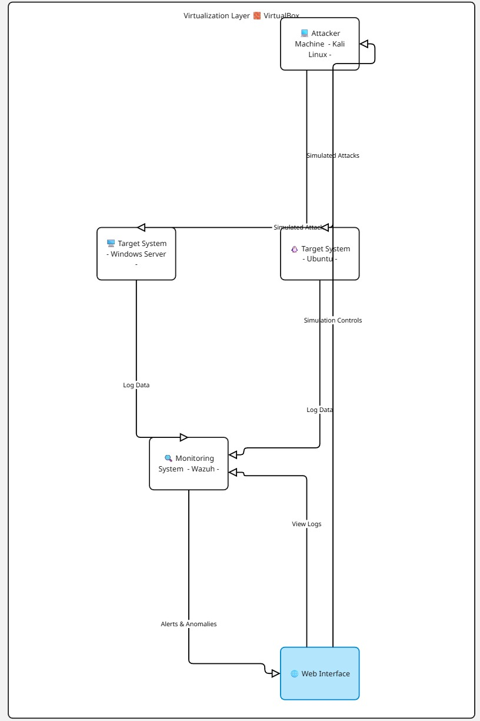

3.4 Structural model:
The Cyber Attack Simulation Lab is designed with a modular architecture to ensure flexibility, scalability, and ease of maintenance. Each module performs a specific set of functions and can operate independently, allowing seamless integration of additional features in the future. The main system modules are as follows:
- Attack Simulation Module
Responsible for creating and executing various cyberattack scenarios in a controlled environment to evaluate system vulnerabilities and response mechanisms.
- Detection and Monitoring Module
Monitors network and system activities in real-time to detect suspicious or malicious behavior using predefined rules, anomaly detection, and threat intelligence.
- Mitigation and Response Module
Provides automated and manual response mechanisms to contain, mitigate, or neutralize detected attacks, ensuring minimal system disruption.
- Reporting Module
Generates comprehensive reports on simulated attacks, system performance, detected threats, and response effectiveness, aiding in analysis and decision-making.
- User Interface Module
Offers an interactive and user-friendly interface for administrators and security analysts to configure simulations, monitor activities, and review reports efficiently.
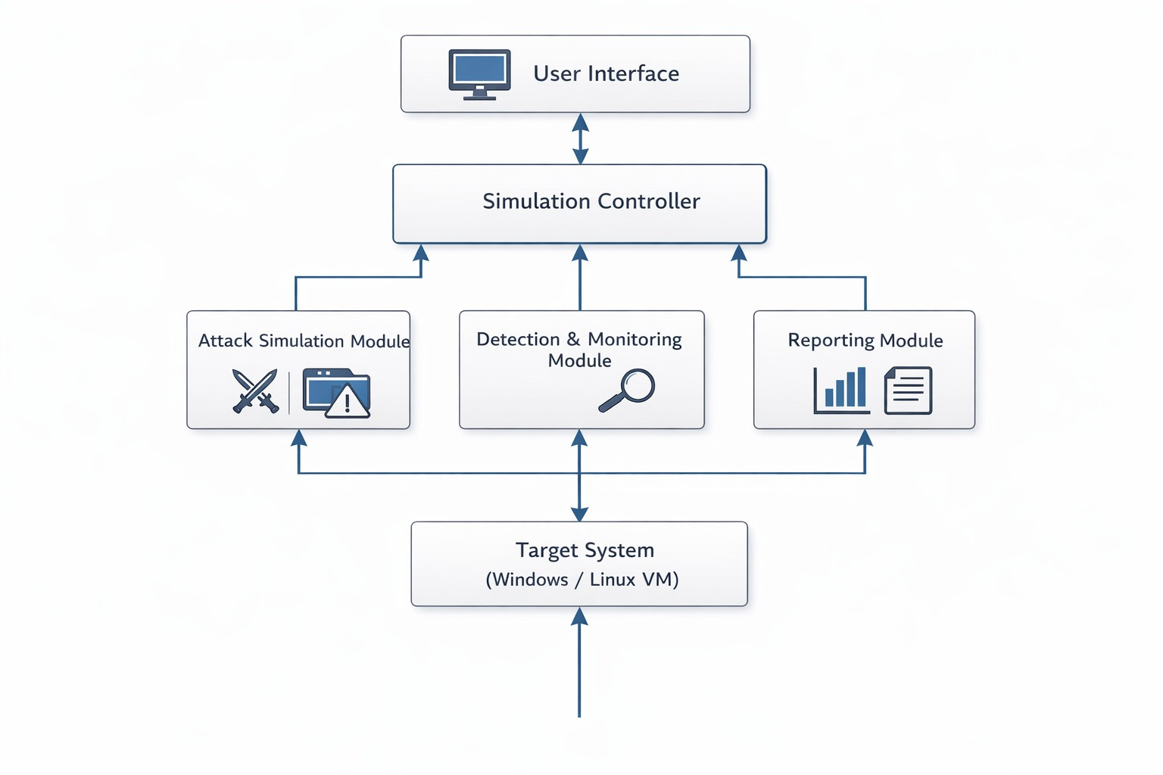

3.5 Detailed System Architecture
Each system component has a specific role within the Cyber Attack Simulation Lab:
• Kali Linux (Attacker):
- Executes penetration testing and attack tools.
- Simulates real-world cyberattack techniques such as scanning, exploitation, and privilege escalation.
• Target Systems (Victims):
- Host vulnerable services and applications.
- Generate logs and system responses during attacks.
• Wazuh Monitoring Server:
- Collects logs from target systems.
- Detects suspicious activities and generates alerts.
- Provides dashboards for analysis and reporting.
• VirtualBox:
- Ensures isolation between lab environments and real networks.
- Manages resource allocation for virtual machines.
• Web Interface:
- Enables users to start, stop, and monitor simulations.
- Displays attack activity, alerts, and system status in real time.

3.6 User Interface
The user interface is designed to be simple, intuitive, and visually informative.
Key features of the interface include:
• Login and registration system for users.
• Dashboard displaying active simulations and alerts.
• Visual representation of attacks and system responses.
• Access to logs and monitoring data for analysis.
The interface enhances user engagement and supports effective learning through real-time interaction.

3.7 Quality Assurance
To ensure system reliability and effectiveness, several quality assurance measures are applied:
• Testing virtual machine isolation to prevent network leakage.
• Verifying attack detection accuracy using known attack scenarios.
• Monitoring system performance under different workloads.
• Validating log collection and alert generation.
These measures ensure the system performs consistently and meets educational objectives.

3.8 Acceptance Criteria
The Cyber Attack Simulation Lab is considered successful if it meets the following criteria:
• The system runs in a fully isolated virtual environment.
• Simulated attacks can be executed without affecting real systems.
• Monitoring tools accurately detect and log malicious activities.
• Users can interact with the system through a functional web interface.
• The lab supports practical learning and skill development.

3.9 Future Consideration
Future enhancements of the system may include:
• Integration of artificial intelligence for adaptive attack simulations.
• Expansion of attack scenarios and defensive tools.
• Cloud-based deployment for remote access.
• User performance tracking and automated assessment.
These improvements can transform the Cyber Attack Simulation Lab into a comprehensive cybersecurity training platform

Chapter Four: Experimental Setup and Configuration

4.1 Hardware and Software Setup:

4.2 Installation and Configuration:

4.3 Tools and Technologies Used:

4.4 System Training (for AI systems)

4.5 Testing and Validation:

4.6 Risk Analysis and Mitigation:

Chapter Five: Results and Discussion

5.1 Results:

5.2 Discussion:

5.3 Limitations:

Chapter Six: Conclusion

6.1 Summary of Work:

6.2 Lessons Learned:

6.3 Future Work:

References
Provide a list of all sources referenced throughout the report, including research papers, books, websites, and tools.

Appendices

A1. Project Timeline
Include the detailed timeline with key milestones

A2. Source Code Documentation
Provide links or attachments to the project's source code and its documentation.

A3. User Manuals
Include user manuals or instructions for using the system.

A4. Additional Diagrams
Provide additional technical diagrams (e.g., detailed system architecture or flowcharts) not included in the main chapters

